Design Principles - Keep It Simple (KISS)
# Source: AI Source: Provided by: [Data Path: Persons Table -> ID Column: 1, Name_En Column: Motasem Essam] -> From: [ChatGPT] on [1/23/2026]
Keep It Simple (KISS) is the principle of designing software so that it is as straightforward as possible, avoiding unnecessary complexity.
👉 Think of it like using a simple, uncluttered path to get from point A to B rather than a maze.

🔑 Key Points
# Source: AI Source: Provided by: [Data Path: Persons Table -> ID Column: 1, Name_En Column: Motasem Essam] -> From: [ChatGPT] on [1/23/2026]
• Complexity increases the risk of bugs and errors
• Simple code is easier to read, maintain, and extend
• Focus on solving the problem efficiently without over-engineering
• Encourages clarity, minimalism, and avoiding clever but obscure solutions

❌ Bad Example
# Source: AI Source: Provided by: [Data Path: Persons Table -> ID Column: 1, Name_En Column: Motasem Essam] -> From: [ChatGPT] on [1/23/2026]
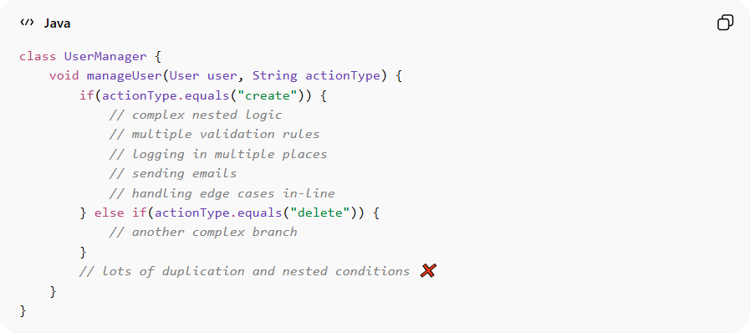
class UserManager {
void manageUser(User user, String actionType) {
if(actionType.equals("create")) {
// complex nested logic
// multiple validation rules
// logging in multiple places
// sending emails
// handling edge cases in-line
} else if(actionType.equals("delete")) {
// another complex branch
}
// lots of duplication and nested conditions ❌
}
}
Problems:
• Too much logic in one place → hard to read and debug
• Adding new actions or rules risks breaking existing functionality
• Hard for new developers to understand

✅ Good Example
# Source: AI Source: Provided by: [Data Path: Persons Table -> ID Column: 1, Name_En Column: Motasem Essam] -> From: [ChatGPT] on [1/23/2026]
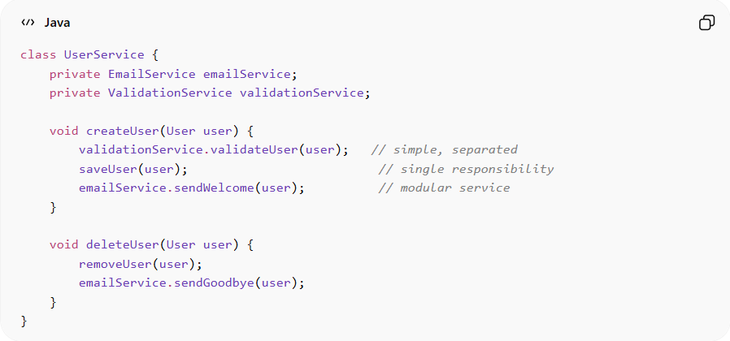
class UserService {
private EmailService emailService;
private ValidationService validationService;

void createUser(User user) {
validationService.validateUser(user); // simple, separated
saveUser(user); // single responsibility
emailService.sendWelcome(user); // modular service
}

void deleteUser(User user) {
removeUser(user);
emailService.sendGoodbye(user);
}
}
Benefits:
• Code is straightforward and readable
• Easier to maintain and extend
• Reduces risk of bugs from over-complicated logic
• Supports modular, testable design

⚡ When to Apply
# Source: AI Source: Provided by: [Data Path: Persons Table -> ID Column: 1, Name_En Column: Motasem Essam] -> From: [ChatGPT] on [1/23/2026]
• Always — simpler code is almost always better
• Especially important in team projects to improve collaboration
• Crucial for long-lived systems where maintainability is key
• Works best with modularity, high cohesion, and clear interfaces

